Article ID: 1141
Article Name: Can I change the sleeve on my Washing Machine?
Topic Location: Laundry, Washing Machine, Door/Cleaning & Maintenance
Meta-data: Gasket, seal, rubber, door
Related Articles:
Related Questions:
PNC
DIY
Safety
Link
Email
Book Engineer
Multimedia
Brand
Article Content:

Replacing the door gasket
Unfortunately you cannot replace the rubber gasket yourself. This is due to the fact that the process is difficult to do, and must be carried out by an expert service engineer. Additionally, there are also safety hazards related to this procedure.

Picture: 1141_WM_Can_I_change_the_sleeve_on_my_WM-JAT-13-11-27
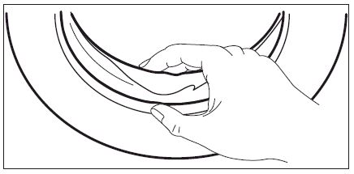
[book_engineer_link]
When you contact us to make your appointment, please ensure that you have the product number (PNC) and serial number of your appliance ready, as this is important information that will assist our engineer when they visit.
Rating plate with model number, product number/PNC, ELC number and serial number:
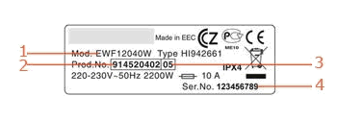 | 1. Model number  2. Product Number  3. ELC number  4. Serial Number
Where to find the rating plate at your appliance: [3-9999] Where to find the rating plate?
Please be aware that depending on your warranty conditions, you may be charged for the visit.
ATTENTION: Do not use the appliance untill the problem is determined. Unplug the appliance from the power supply, close the water supply and make sure, that nobody in your household re-plug / re-open it or tries to use the appliance until it is repaired.

